Contents

1. Megan’s Idea
2. Yellowberry Summary
3. Yellowberry Team
4. Media
5. Distribution

6. Current Product

7. Future Product

8. Financials

9. Marketing

10. Testimonials

Megan’s Idea

Yellowberry began with a simple idea to empower young women by creating a colorful, age appropriate bras that are stylish, colorful and, designed for young women.

Megan’s idea for Yellowberry began while shopping for bras with her younger sister, Mary Margaret. Megan was seventeen and Mary Margaret was thirteen. Unable to find what the two girls thought to be a good looking well made product, and frustrated with the box store lingerie companies selling a message that Megan thought overly sexual and inappropriate for her sister, Megan knew she could do better.

It was a simple idea really. Create an age appropriate product that girls loved. Designed for girls that were interested in a great product full of style, quality, and originality while sending a message of female empowerment to young women all over the world.

During the winter months of her junior year of high school at Jackson Hole Community School, Megan started Yellowberry. After countless drawings, fittings, fabrics, a lengthy trademark application and finally website development, Yellowberry’s first prototypes were complete and inventory was for sale in February 2014.

With the original Yellowberry bra, the Tweetheart and one other style for sale exclusively on yellowberrycompany.com Yellowberry was officially in business.

Yellowberry Summary

Lingerie has long been sold and marketed inappropriately to young girls. Young women all over the world are introduced to a product that is sensual and provocative at the age of twelve. Domestically, our culture is in the middle of a refocus. Young women and their mothers are gaining a voice. They are demanding a product that is both functional and age appropriate. Yellowberry is focused on marketing, manufacturing and selling products that will enable young women from all over the world to feel empowered. Yellowberry is committed to offering a quality product that is great looking, well made and with a story behind these pieces of lingerie that will forever change the lingerie industry.

Central to our mission is providing young women a product that we believe is largely overlooked and incorrectly marketed in our world. By offering an empowering message and fresh emboldened product and by leveraging new media tools for social networking, digital catalog distribution and direct response sales, we will re-brand an industry that we believe is a hundred million dollar mega-niche.

Our solid mantra is innovation and design based on the wants and needs of young women. Yellowberry is the vehicle that will forever link women to a new path for their bodies and enhance an industry that has largely overlooked and misunderstood young women for centuries. Our product will revolutionize the current offerings and make bras an empowering vehicle for women all over the world.

Yellowberry Team

Navigating this multi-channel path requires expertise that spans both social media, all web based introductions, wholesale and retail markets, as well as creative innovation of product design. The Yellowberry Company has not been developed by experts in the lingerie industry rather it is born by a young women, for young women. Yellowberry’s design innovation and expertise consists of and will remain the voice of young women from all over the world.

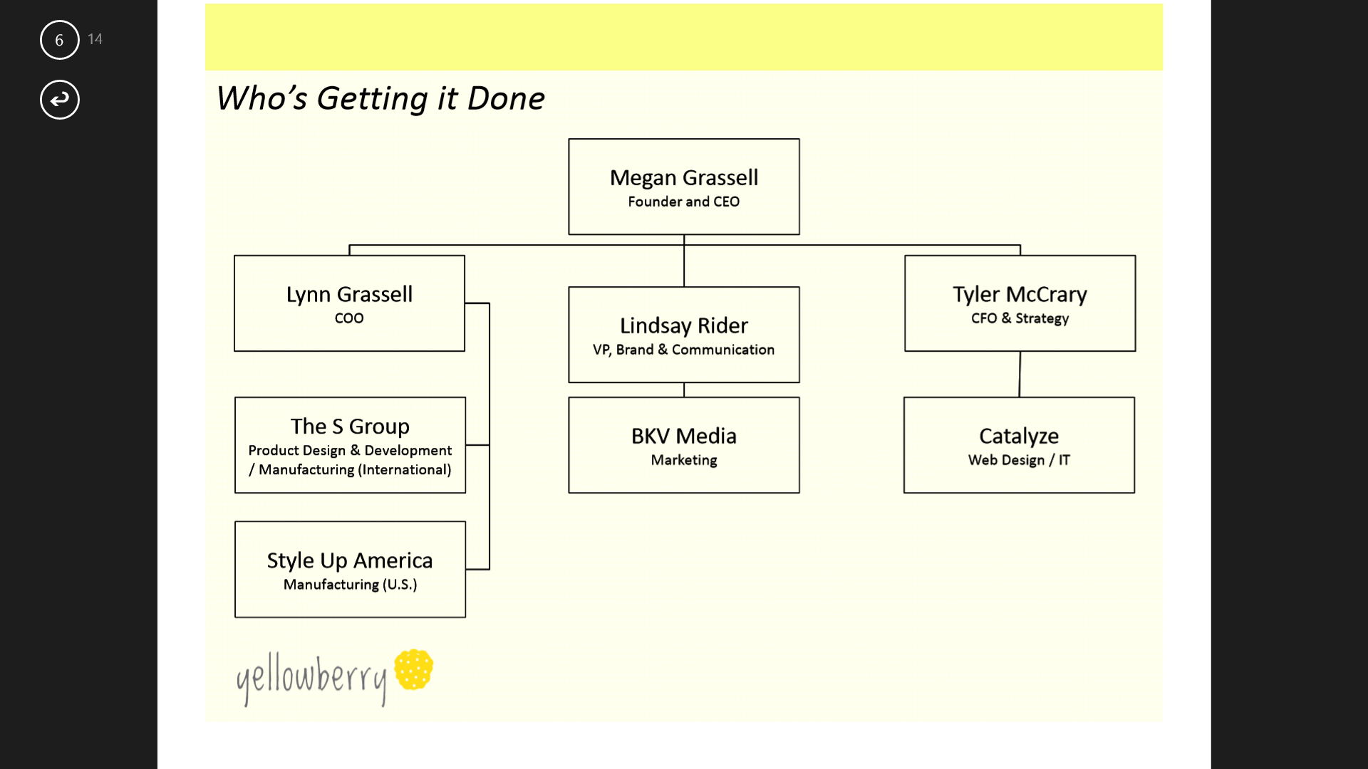

Megan Grassell Owner/Founder of the Yellowberry Company, Brand development

Lynn Grassell Production, Product Development.

Chopper Grassell Financial planning, analysis

Guy Turck Website designer, IT

Jenny Francis Customer service, Creative, AI

Media

* [**CNN Money/Fortune** Yellowberry founder Megan Grassell's business crash course](http://management.fortune.cnn.com/2014/04/22/yellowberry-megan-grassell/)
* [**A Design So Vast** Raising strong girls](http://www.adesignsovast.com/2014/04/strong-girls/)
* [**Yummy Mummy Club** Teen Kickstarts Revolutionary Bra Company For Girls](http://www.yummymummyclub.ca/blogs/mummy-buzz/20140420/teen-kickstarts-bra-brand-for-girls)
* [**Slate.com** Finally, a Training Bra for the 21st Century](http://www.slate.com/blogs/xx_factor/2014/04/16/yellowberry_bras_megan_grassell_18_designs_training_bras_for_modern_tweens.html)
* [**CTV News** From Kickstarter to sold out: How a teen is shaking up the lingerie industry](http://www.ctvnews.ca/business/from-kickstarter-to-sold-out-how-a-teen-is-shaking-up-the-lingerie-industry-1.1780010)
* [**Huffington Post** How One Fearless teen is starting a bra revolution](http://www.huffingtonpost.com/2014/04/16/megan-grassell-yellowberry_n_5160099.html)
* [**Lingerie Talk** Yellowberry: Meet the Teen Titan Who Is Taking On The Youth Bra Industry](http://www.lingerietalk.com/2014/04/08/lingerie-news/yellowberry-meet-the-teen-titan-who-is-taking-on-the-youth-bra-industry.html)
* [**CNBC.com** No push-ups: Young entrepreneur launches bra line using Kickstarter](http://www.cnbc.com/id/101582249)
* [**POPSUGAR** A Fashionable Line of Bras For Teens, by Teens](http://moms.popsugar.com/Age-Appropriate-Bras-34582241?ref=33921860#opening-slide)
* [**BlogHer** Yellowberry Bras](http://www.blogher.com/yellowberry-bras)
* [**A Mighty Girl** 18-year-old Mighty Girl Megan Grassell was shocked...](https://www.facebook.com/amightygirl/posts/651607241542259:0)
* [**The Uncommon Feed** How A Failed Shopping Trip Is Changing The Bra For Young Girls](http://uncommonfeed.com/2014/03/how-a-failed-shopping-trip-is-changing-the-bra-for-young-girls/)

[**JH Style Magazine** Teen Visionary Fills Niche in Youth Market](http://www.yellowberrycompany.com/media/JHStyle%20Yellowberry.pdf)

Distribution

Yellowberry is concentrating on one distinct channel of distribution —online sales through www.yellowberrycompany.com.

Yellowberry receives bras in bulk from manufactures in Los Angeles and Ft. Lauderdale. We currently have our home garage space set up as a distribution center. All products are mailed though the USPS on a daily basis and overnight orders are given priority.

Because we have been contacted by Nordstrom, American Eagle and Kohls, all of which have expressed an interest in carrying the Yellowberry products, our next step would be to investigate a wholesale market for Yellowberry.

Current Product

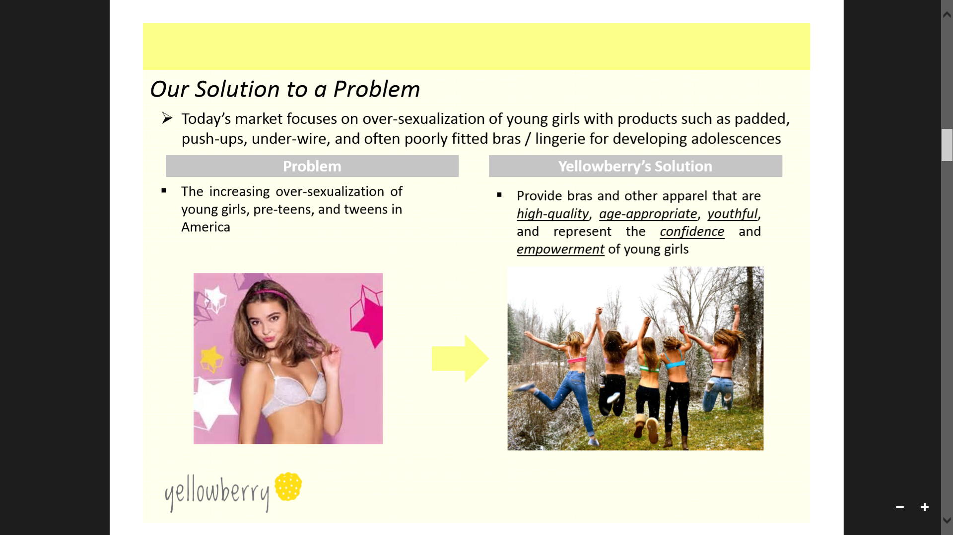

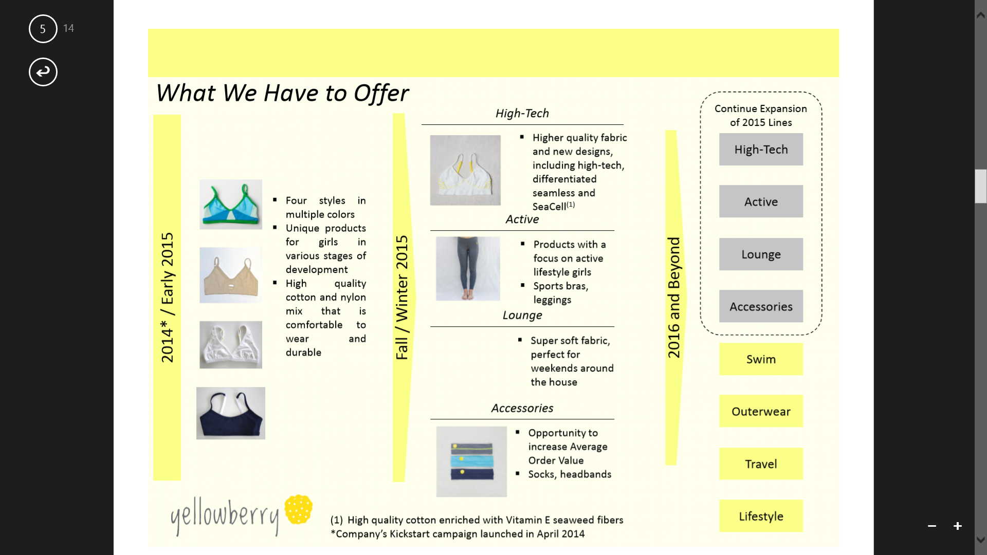Yellowberry developed six bra styles to begin. Styles include two colors and four sizes of each style.

1. **Tweetheart**  90% cotton, 10% spandex (we searched high and low for this fabric), three colors, and contrast stitching. Free of metal hooks and wires, fully lined in the same cotton/spandex fabric ensuring soft wear with our bright Yellowberry logo embroidered on the back.

1. **Tiny Teton** Inspired by Megan’s sister Mary Margaret, this cute, comfortable bra is great for the first time bra wearer. Boasting substantial 90% cotton, 10% spandex, the Tiny Teton is light and not padded, but styled with appropriate coverage. Both Mary Margaret and Megan love the styled keyhole and the darling embroidered Yellowberry logo on the back.

1. **Budding Berry** A true “can’t have enough” basic. The Budding Berry exterior fabric is constructed of 85% cotton and 15% spandex. The lining is constructed of 88% nylon and 12% spandex. The criss-cross design offers a triangle neck-line perfect for wearing under dresses and v-neck shirts. With adjustable straps and no hooks and wires, the Budding Berry also has a little more fabric to allow room to grow!
2. **Bug Bite** Constructed of 84% brushed polyester and 16% spandex. The lining is constructed of 88% nylon and 12% spandex. We’re so excited because it is our first true sports bra! Girls can run, jump, dance, and cartwheel to their hearts delight. With adjustable straps and no hooks and wires, the Bug Bite is comfortable and low-key and we are thrilled with the adorable striped fabric.

 Future Product

Additional bra styles, sleepwear, panties and accessories are Yellowberry’s next step. Additionally, we are exploring Yellowberry water bottles, backpacks, soccer balls all printed with the Yellowberry logo.

1. **The Tree Hugger**

Available in six colors this panty is one that you will not soon forget. It has enough coverage to please parents yet leaves the granny panty in the dust.

1. **The Moderate**

A bit less coverage than the original, this panty is distinctive for it’s two color pallet and seamless style. Great under a dress or a school uniform.

1. **The Youngster**

Full coverage for the soccer uniform or ski suit. 100% cotton and purely breathable for the youngest budding Yellowberry customer.

Financials

Yellowberry’s initial start-up capital was $25,000.00. Currently, we have paid for all textiles, shipping boxes and wrapping materials to ship 4500 bras, paid for development costs of six bra styles, created a Yellowberry video for marketing and as a website tool and have fully paid for and launched the yellowberrycompany.com website. We have no past due or unpaid bills. Yellowberry inventory currently in production has not been prepaid.

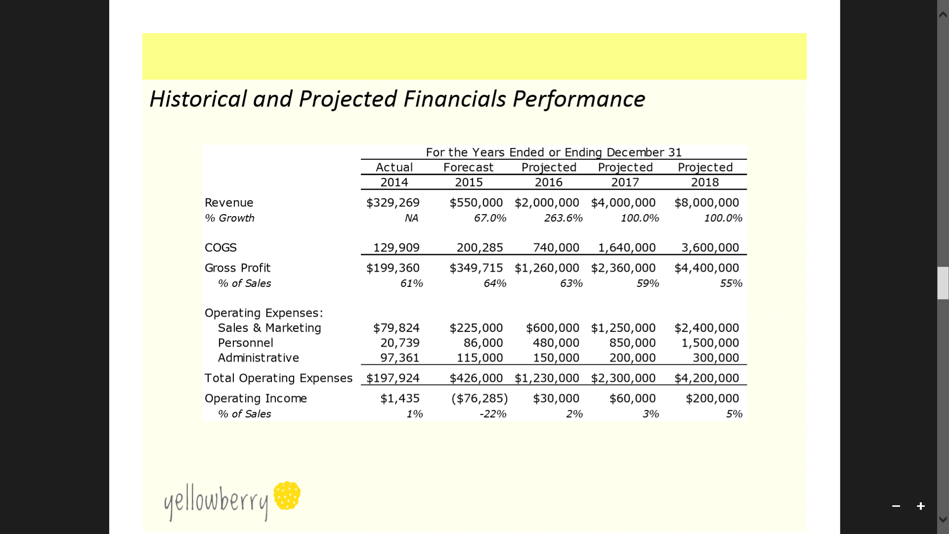

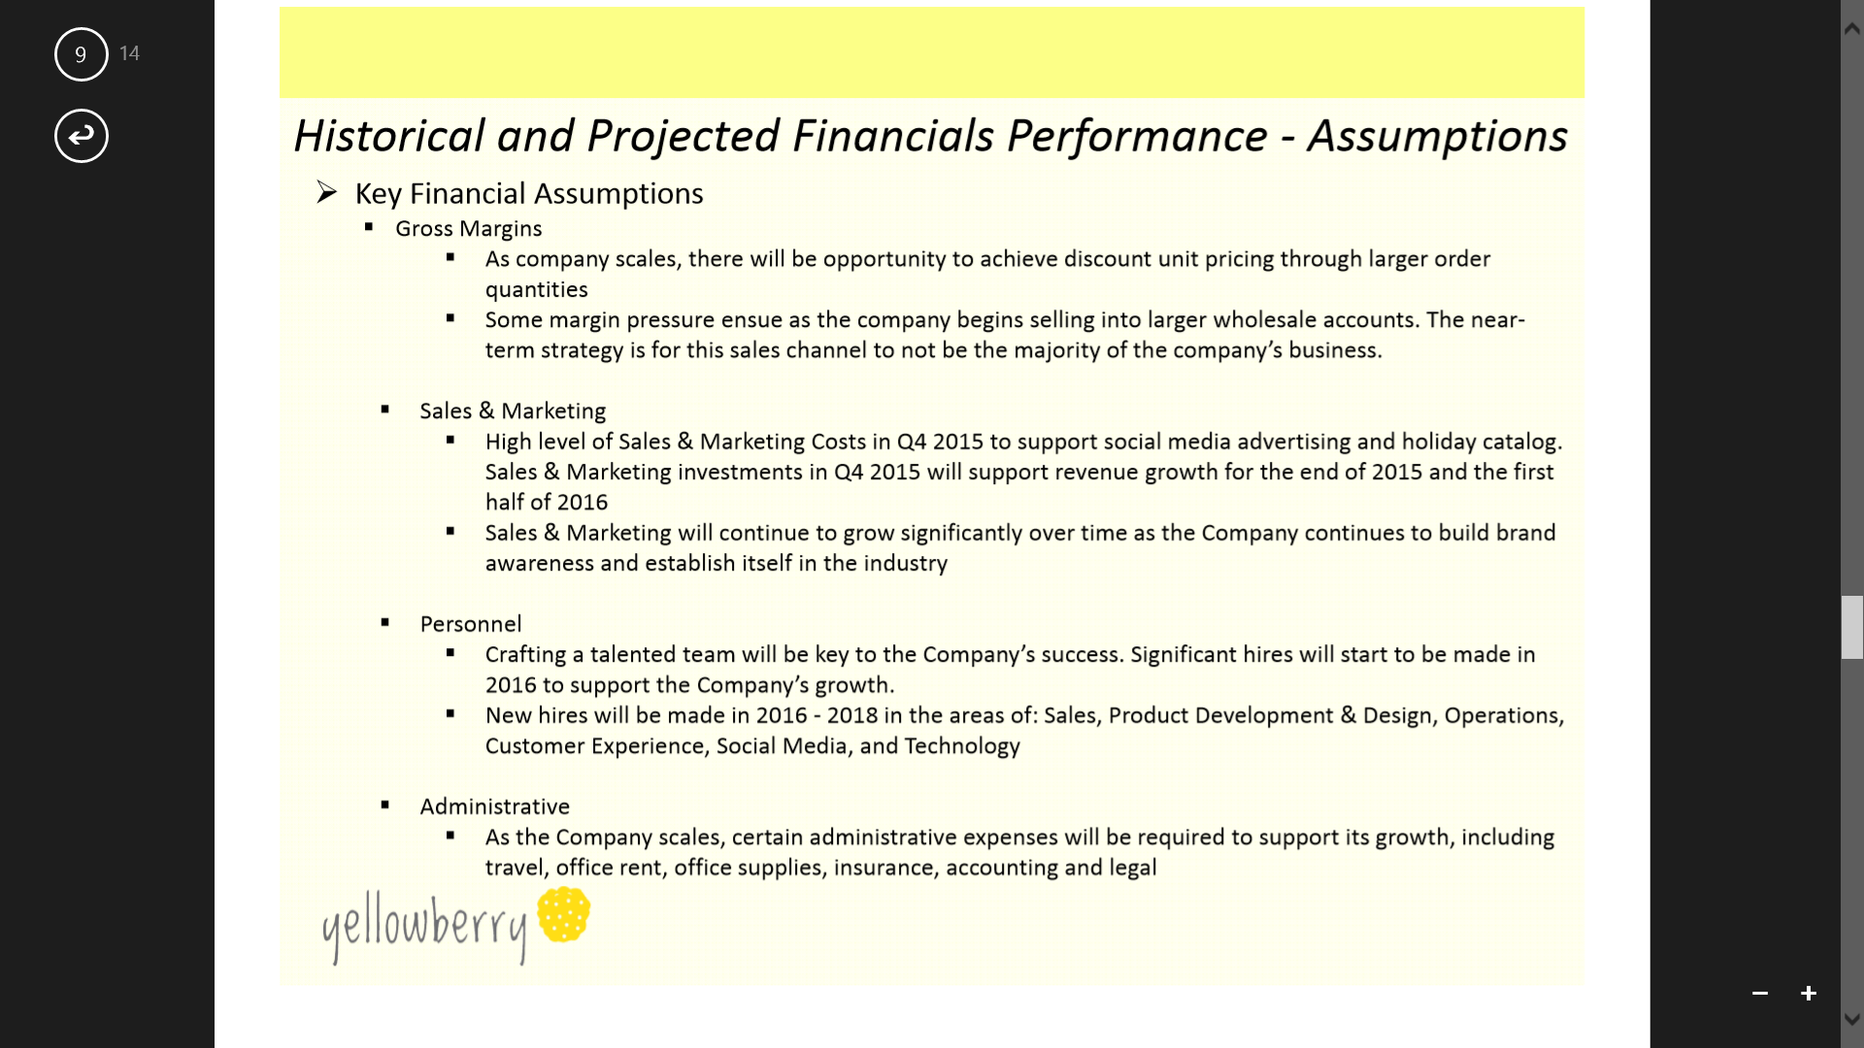

** Marketing**

Yellowberry is as much a statement to girls about a lifestyle as it is a product to market. Yellowberry differs from other bra companies on the market, because Yellowberry’s purpose is to produce bras for developing girls that celebrate their young age with no attempt to sexualize their bodies.

A girl myself, I have grown up in a society that often pressures girls to look, dress, and present themselves a certain way.  Yellowberry combats that with bras that are targeted at the 11-15 age group that are made for their realistic bodies.  There is no extra padding made to enhance breasts, underwire designed to “push-up” breasts, or any features specifically designed to change or alter a young girls breasts.

Yellowberry promotes a youthful lifestyle through six main taglines:

Water the flowers everyday

Go Barefoot

Watch Quietly and Observe

Seek and find a hug when you need one

Love the outdoors and nature

Campfires are rare, so eat as many marshmallows as you can

Marketing Budget Projections

Plan 1 $30,000 monthly sales / $360,000 year sales

15% - $4,500 per month 8% - $2,400 per month

$54,000 yearly $28,000 per year

Online advertising $1,500 m, $18,000 y $500 m, $6,000 y

Digital marketing, newsletters $2,500 m, $30,000 y $1,700 m, $20,400 y

Social media advertising $400 m, $6,000 y $200 m, $2,400 y

Direct mail - postcards, catalogs, or letters $0 $0

Advertising (print, radio, cable, out-of-home) $0 $0

Marketing materials (business cards, flyers or brochures) $100 m, $1,200 y $100 m, $1,200 y

Plan 2 $100,000 in monthly sales / $1,200,000 in yearly sales

15% - $15,000 per month 8% - $8,000 per month

$180,000 per year $96,000 per year

Online advertising $6,000 m, $60,000 y $3,000 m, $36,000 y

Digital marketing, newsletters $2,500 m, $30,000 y $1,700 m, $20,400 y

Social media $2,500 m, $30,000 y $1,500 m, $18,000 y

Direct mail - postcards, catalogs, or letters $1,500 m, $18,000 y $500 m, $12,000 y

Advertising (print, radio, cable, out-of-home) $2,000 m, $24,000 y $1,000 m, $12,000 y

Marketing materials (business cards, flyers or brochures) $500 m, $6,000 y $300 m, $3,600 y

Plan 3 $300,000 per month / $3,600,000 per year

15% - $45,000 per month 8% - $24,000 per month

$540,000 per year $288,000 per year

Online advertising $20,000 m, $240,000 y $10,000 m, $120,000 y

Digital marketing, newsletters $2,500 m, $30,000 y $1,700 m, $20,400 y

Social media $5,000 m, $60,000 y $3,500 m, $42,000 y

Direct mail - postcards, catalogs, or letters $6,000 m, $72,000 y $3,000 m, $36,000 y

Advertising (print, radio, cable, out-of-home) $10,000 m, $120,000 y $5,000 m, $50,000 y

Marketing materials (business cards, flyers or brochures) $1,500 m, $18,000 y $800 m, $9,600 y

